Installation and Running:
- Install JDK 1.4.0 or later versions.
- In Control Panel → Regional and Language Options, set Hebrew as Default language.
- Download MED classes from the Download section (public_html\bin.zip and public_html\sources.zip)
- Unzip the project.
- Change the current directory to directory where run.bat file is located (to the same directory you extracted the zip files).
- Create new ODBC connection (using "odbcad32.exe" utility) named "med" which is pointing to attached MED.mdb file (Microsoft Access Driver).
- Launch "run.bat" to start the system.
- Please see our web-site (located in public_html) for additional information.

Special features:

  - UNDO/REDO - System supports unlimited undo/redo functionality. When user wishes to cancel last operation, he should click on undo button of the toolbar or in the system menu (under Edit folder). The system also returns to the screen where the last change had been made. (Redo/Undo remember the screen-location of the action)

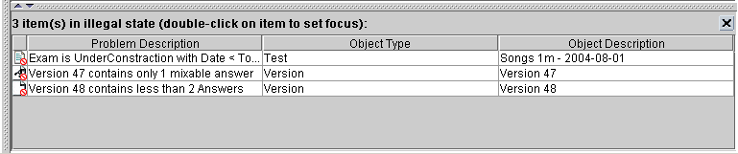
  - Error states panel – when some object is not in correct state, indication of this will appear in the panel in the bottom of each screen. Click on each of these errors will “jump” to the screen where this error can be fixed.

  - Printed text features - bold/underlined/italic – when editing a text field it is possible to set a kind of text printed by clicking on buttons on the toolbar

  - Personal settings - user is allowed to choose his preferences through system menu – Options/Settings. These options are saved in an external xml file (which is automatically created if doesn’t exist), loaded with the system and updated by the user through the above mentioned menu:
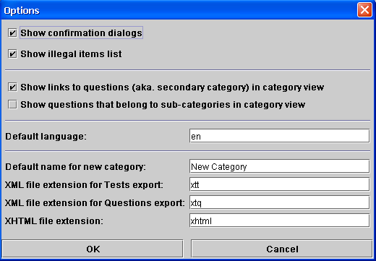

  - State–sensitive menus – when user is in certain panel he is allowed to choose in the system menu only options relevant in the current context. Other options are disabled. Popup menus are different in different context, as are the icons on the toolbar. Common tool-bar buttons like import, export do different things in different screens (the tool-tip explains what)

  - Multi-Selection support - when user wishes to choose number of rows of table (for instance versions) and perform some operation with them (add to exam) the system will try to do it. In case that number of operations could not be performed the system will announce about those operations:

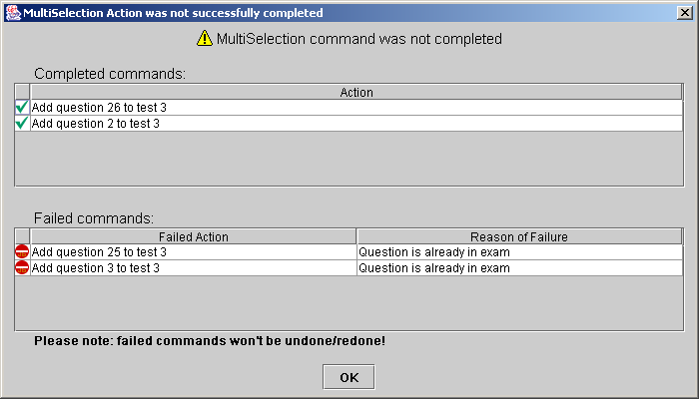
  - When importing students replies from a file, a detailed description on success and failures are given by the following screen:

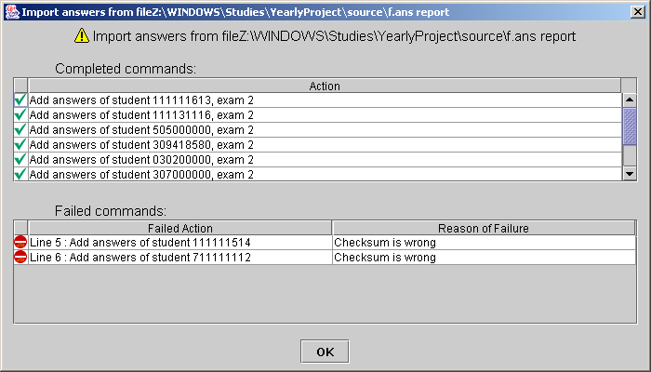
  - Exporting students grading sheet with information about success of student in each category itself as well as its subcategories – in system menu Test/Make grades report or through popup menu of exam node. This html page is constructed such that the hierarchy of the categories is clear and colors are used to identify problematic test sections for the student. The page can be customized by the user by changing an external text file (images/text/InfoPageExplanation.txt).
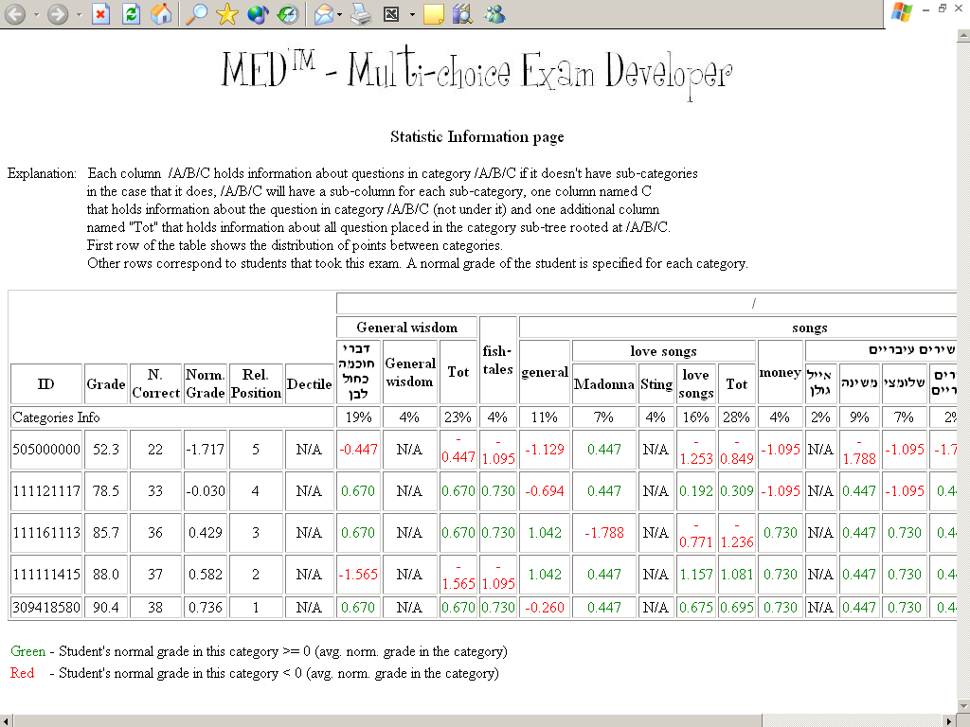

  - Context sensitive help – when user drags mouse over some object he sees some useful information about this object

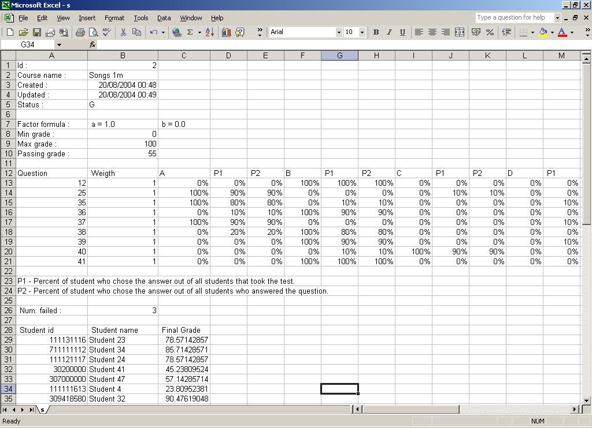
10. Exporting grading information to Excel (CSV format) – in order to make user changing grading policy in more convenient way MED allows exporting all the relevant information. This is done in a very user friendly way:

11. Context sensitive statistic information: both when walking on categories trees (sensitive info for selected category, question, version and answer) and test tree (info for selected test category, test version and test answer)

- Extensive statistic information: additional statistics beyond required, screens with additional charts and other forms of visualization.

- Save-As screen allows many options including opening the web-browser for preview of the printed test, specifying number of copies to be printed and other things, all this in a compact and user-friendly way.
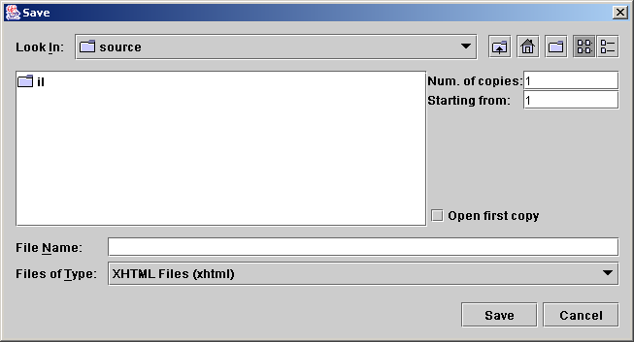
- Full multi-lingual support – when editing text in the program, it is possible to change text alignment in the editing area, each question (exam-version) in a test is printed on the xhtml page aligned according to the language of its body. The language must be also set in the operating system as the local language in order to enable this feature.

- Easy to use GUI: For instance, many tables can be sorted by pressing on a column header, user can press on some row of the errors-panel and this will jump him right to the problematic object. The students replies screen can jump the user to a specific student-replies screen by pressing on its row.

- Built in printing of empty replies sheet: the user can print from within the program the following html sheet:
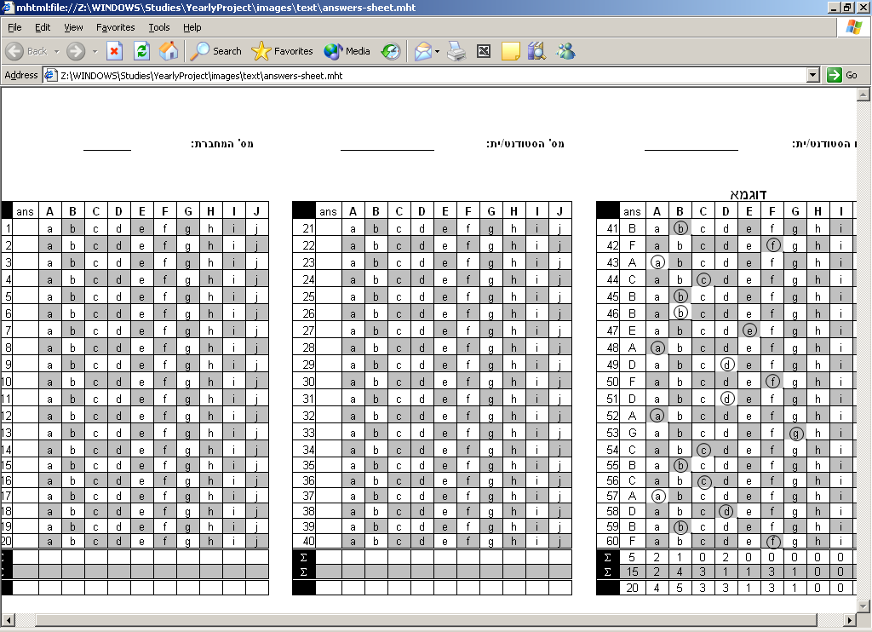
- Full drag and Drop support

18. Web site and documentation: The website is built to be as friendly and as extensive as possible, including animation and full documentation for the use of the next generation students.

